Guided Technology Project – Project Report

STOCK WALLET CLOUD-BASED WEB APPLICATION

Higher Diploma in Science in Computing (Award)

AUGUST 2020

By

Gibran Rubinger



# **Abstract**

# This application was made as guided technology project at CCT college. an application responsible for home broke stock management. With this application, user can build your custom dashboard to better understating what is going on in your investments. an easy application that can allow any people with very basics knowledge on the stock market to build a portfolio.

# The principles behind this project were to take advantage of the experience of developing a full-stack application able to the simulated real industry environment in software development life cycle. it was a great opportunity to put in practices all the lectures experienced during the course and learn such many other newest technologies we can face in the industry.

# the idea for this application comes from my experience using the invest.com website/application. thinking about the user experience, for a beginner investor the dashboard full of tools, projections and options become more confused than helpful. this particular point of view thought the user experience was the trigger to develop this application. during the development, the key point was always for a search for features able to provide solutions between front-end, API, backend and databases.

# **ACKNOWLEDGEMENTS**

First and foremost, I would like to thank all the professors who throughout my academic journey gave me all of the support necessary, encouraged me to continue looking for answers to solve problems faced during the course, encouraging me not to take the easy path, but

path of learning, shown me the most important to achieve greats marks, is the knowledge accomplished during the process.

I would like special thank, my family and wife, for always pushing me during in the correct direction along this journey, To the good friends that I had the opportunity to meet while walking the course and captivate as people of reference, loyalty and future partners in this new journey.

I would like to thank the CCT college who had allowed me to learn valuable teachings about in Science in Computing and life.

# **Contents**

First

# **CHAPTER I:**

# **INTRODUCTION**

# Project motivation

# the idea for this application comes from my experience using some websites and applications such as investing.com, bloomberg.com and b3.com.br. Thinking about the user experience, for a beginner investor the dashboard full of tools, projections and options become more confused than helpful. This particular point of view thought the user experience was the trigger to develop this application.

The stock market is something I am quite interested and the difficult to find easy tools to watch what is going on simply comes to my mind this idea. As the genius, Warren Buffett says

*“The majority of business schools reward difficult complex behaviour more than simple behaviour, but simple behaviour is more effective.”*

**Warren Buffett,brainyquotes.com.**

# I will build a web application on spring-boot microservices following the principle of Object Relational Mapping – O.R.M. it will be a great achievement for me. This project is a great opportunity for starting to expose me to this environment. This achievement will help me a lot and I have the opportunity to use this application in my further portfolio.

# during the development, the key point was always searching for features able to provide solutions between front-end, API, backend and databases.

# Guided Technology Project

Before starting the explanation around the project itself, it makes the importance of clarifying what is the Guided Technology Project and how this is an amazing opportunity for students challenger himself true a new experience to the development a full-stack application. During the course at CCT College, the students had to experience wide knowledge true the science computer fields and the guided technology project is the first experience to try to put all of the knowledge together. The requirement to built this application as full-stack allows the student to experience develop a software development life cycle.

The opportunity to plan, design, implement, test and document, is the main goal as describes on the CCT Guided Technology Project Handbook:

“*The skills and knowledge gained from subjects in previous semesters, such as Software Development Fundamentals and Databases, will aid the learners in structuring the project according to an SDLC methodology.*” “*In terms of analysis and design of the proposed system, where individuals will identify how the system should work and what problems need to be addressed in the development of the system.*”

**March 2020, CCT Guided Technology Project Handbook v4.**

# Project context

On the stock market, most of the platforms are super complex to use, the idea is built a cloud base web application for home broke stock management. This application will help everyone interested in the stock market. With this application, user can build your custom dashboard to better understating what is going on in your investments. This system will allow any people with very basics knowledge on the stock market to built a portfolio in a runtime platform that allows users to register a login and use this application in many devices. The system will respond to produce custom storage, built useful calculations and projections, catalogue with date and price for which bought stock, quantity and so on.

# Target

My target user would be non a professional trader but everyone seeking for easy application who can customise a cleaning platform. This idea becomes from my personal experience thought some existing applications (the majority mobile non-cloud-based web application) that prints so many information on the screen that it’s become a mess for nom professionals. Even if you have some previous experience, at the end of the day the investor is looking for answers. To have quickly understood the portfolio is the golden ratio. Before you decide to invest in some company the picky analyses thought balances per year and decades projections, reading all complex analyses and so on, should be taken before to buy.

To have this kind of information at the same platform for nom professional could increase extra complexity and miss some important facts. In nutshell, the idea for this application is to keep the core and make the vision clear for the further projections.

That was my main motivation, develop an application easy to use, easy to read and able to access for any device you have with an internet connection, the main functionalities are:

* The user would be able to make registration and login, the app needs store:
* Name, e-mail address and password.
* A user would be able to search for stock and see the day price.
* User can track stocks in the custom dashboard:
* User can save stocks on the stock wallet:
* Stock Name, quantity, purchase date and price.
* A user would be able to track the profitability or loss during from the purchase date.

Once register and login these functionalities descript above will be responsible in the dashboard. The focus on the user experience during the trade tracks, the user will be able to understand the price movements after purchase, how the profitability or loss during the time since the purchase to the current date.

Goals

1. Build a cloud-based web application for management of home broke stocks.
2. Learn new features technologies that have not ministered during the course.

Requires knowledge

For this application to work properly it will necessary many of the knowledge built during this course. The lectures built some important paths experience through the way of coding, some important understanding of structure, syntax and deploying where made. Now with this project, an important opportunity is facing to put all the knowledge together with new ones it will be necessary.

The main languages ​​it is needed to build this application are HTML for the front-end, Java for the back-end and Mysql to the database. The interconnections between front-end, back-end and database is a new challenge for me and I am delighting this opportunity to expands my knowledge in some important features that will help me during further opportunities at the IT industry. New code languages ​​are necessary to learn to guarantee the correct functionality, and many skils will be involved to guarantee plain scope.

The Venn diagram below was developed to show all the technologies necessary in this application:

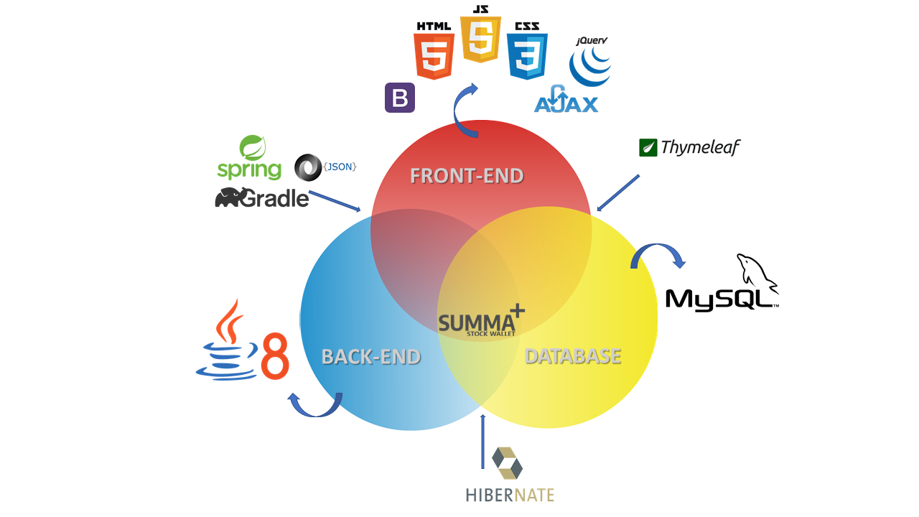

Figure - Venn Diagram - all technologies necessary during the development.

Tools and languages

As shown in the diagram above the technologies involves are:

* **Front-end**
  + **HTML**: the main language on the front-end will be code in HyperText Markup Language.
    - **CSS:** the cascading style sheets will be used to set a customised style.
    - **JavaScript:** will be used to build some custom movement.
    - **BootStrap:** this framework will be used to produce responsive designs.
    - **Jquery:** this library will implement some javaScript accomplish.
    - **Ajax:** will be used to make asynchronous to the JSON objects.
* **Back-end**
  + **Java**: the main language on the back-end will be code in java.
    - **SpringBoot:** will be the restful API.
    - **JSON:** will be used to pass the objects.
    - **Gradle:** Will be used as java build and deployment tool to set all the dependencies necessary and JVM.
    - **Thymeleaf:** will be responsible for the server-side Java template engine for both web and standalone environments.
* **Database**
  + **Mysql:** the most used database management system.
    - **Hibernate**: will be used to map [object-oriented](https://searchapparchitecture.techtarget.com/definition/object-oriented-programming-OOP) domain models to relational databases.

During the development process, in the next chapter 4 – implementation of the system all of these technologies will be detailed as the steps are due.

Why is a good project?

It seems to be a good project as the idea of development comes from my experience trying to use the standard application available in the market. Instead, to over-complicate the dashboard populating with many projections and valuations, the idea is to develop an application minimalist that can be used for anyone.

The most important achievement is to have the chance to create a full-stack application. It is a great opportunity to put in practices some of the important knowledge developed during the course.

# Project plan

The steps of the software development lifecycle were taken during the sketch process to develop this project. This process seems to be a great tool to guide me during the internal process. It can repeat some times moving step to step, producing a kind of feedback to improve any changes necessary. It can anticipate some further problems and with features can be necessary to achieve the goals of this project. To clarify more how the software development lifecycle was used I will breakdown the SDLC structure on the next step below:

**Feasibility**

for example, when I start the sketches many of the feasibility points pop in my mind as the SWOT analysis we had developed on the Strategic Business Information Technology lectures. what was the expertise should I searches to achieving my goals? What are my strengths and so one? This was a good way to start the process, putting the focus on the new features that I need to learn to be achieving my goals.

**Requirements Analysis**

what are the particularities necessary for the target users? how many scenarios how people will use this? what are the languages and features will be needed?

At this point, my focus is on how the design can help the users to navigate between the application itself and with kind of problems could be avoided on the back-end side. How the design propose can avoid extra coding, how some functions can be avoided just choose the correct design and approach.

**Design**

This point is one of the most important during the process. To change the logical design concepts to a physical design. this is the point when everything gets very confused. The diagram below we can see how these gaps are related to each other during the design timeline process.

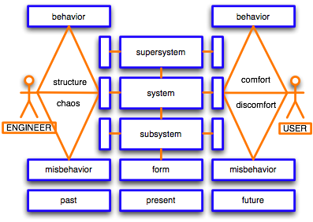

Figure - Design diagram thinking

As the first experience for this type of development understand all the layers involved during this process is something just became with practices, I am so grateful to have the opportunity to have my first experience it before to take a position at the industry.

**Code, test and maintenance**

At this moment should be the moment to put the previous steps in practices, but unfortunately at the moment I am writing this report I had tried such so many codes to try to solve the physical design before to it have finished the requirement analysis and logical design. That became to me the most important lesson of this project! The anxiety to have everything works and learn all the new features can’t put over the previous steps. As an analogy of this process now come to my mind that before to raise a building the foundation must be done.

# Gantt Chart

Gantt chart management is a methodology to track events in the timeline process developed by Karol Adamiecki and Herry Gantt in the latest 19th century and early 20th.

“*Originally Gantt charts were prepared laboriously by hand; each time a project changed it was necessary to amend or redraw the chart and this limited their usefulness, a continual change being a feature of most projects.* ”

After a search for a long time, I found an open-source Gantt Chart project management that works Agantty. Before to get this one I had downloaded some previous but wasn’t work properly. Now with a correct tool will be possible to track all the task necessary for this project.

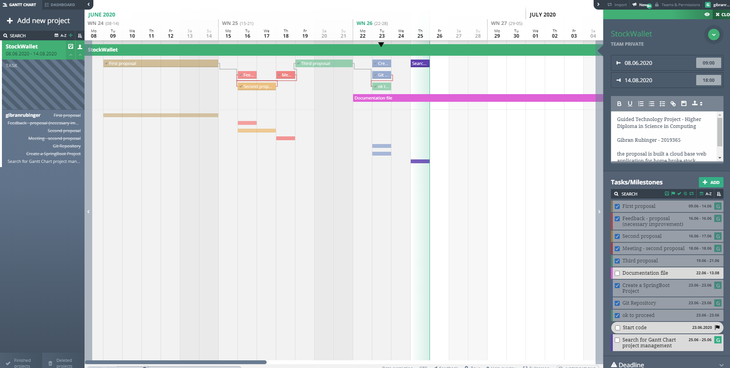

Figure – screenshot of the Agantti App

26.06.2020 – Friday

Today in my first task, I finish the scope for my draft plan (project management):

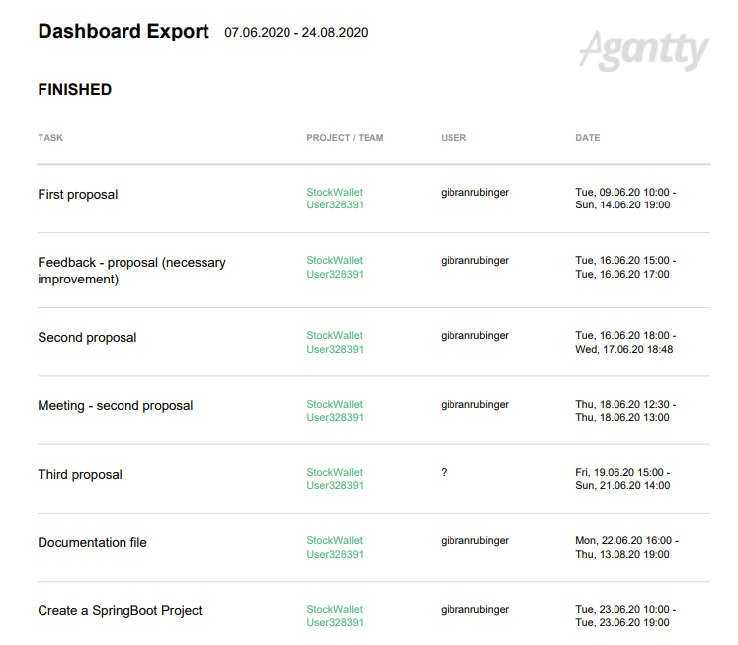

Figure – Screenshot of the dashboard project.

Methodology

The methodology using is the agile process. This methodology is the four principal steps are the individual and interactions, the working software or documentation, customer collaboration (in my case will be myself), and responding to change.

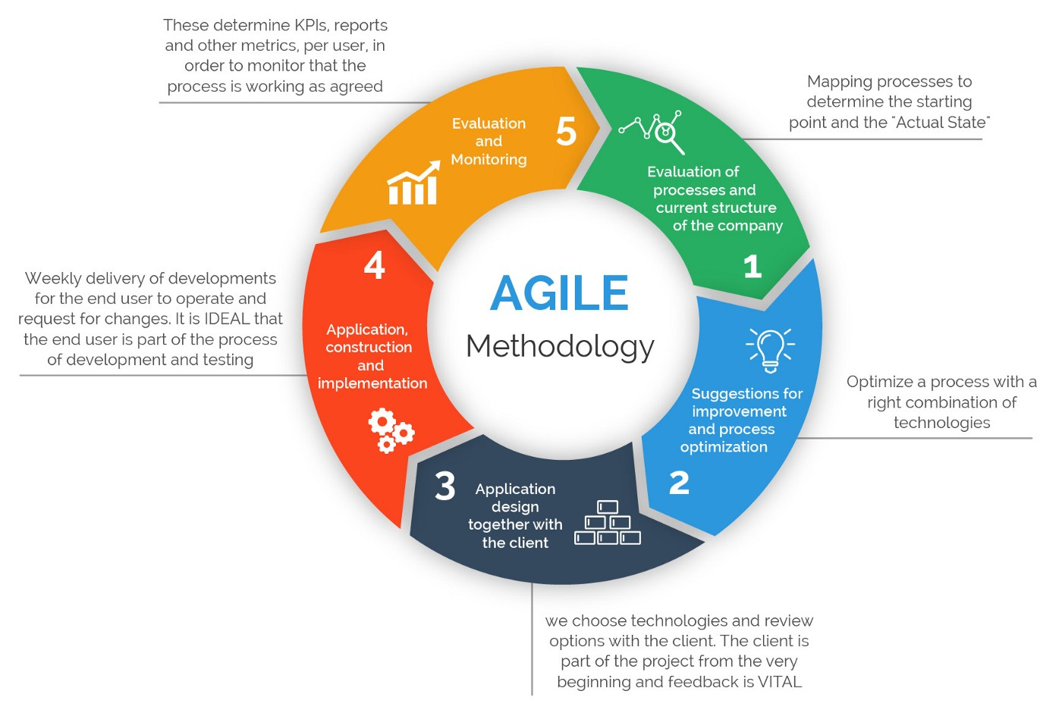

Figure - agile methodology process - picture from medium.com

# **CHAPTER II:**

# **Literature review**

This chapter will responsible for shown all of the academic researches made during this process. This is a good practices writedown the literature review used to solve the unresolved and inconsistencies gaps existing in the project. However, as the majority of subjects are related to java, some of them still being new for me.

This approach will provide a better understanding of the background necessary and will highlight some other important point learned during the entire process.

Process and current structure

As discussed in the previous chapter, this process will be breaking down by the process. I will write down all the process since I had started this project and I hope it can provide a better understanding during all process:

**Github Repository**

After I received the approval from Ken and Amilcar to proceed with the proposed project. The first step before starting the project was created a Git repository to track all the changes during this project:

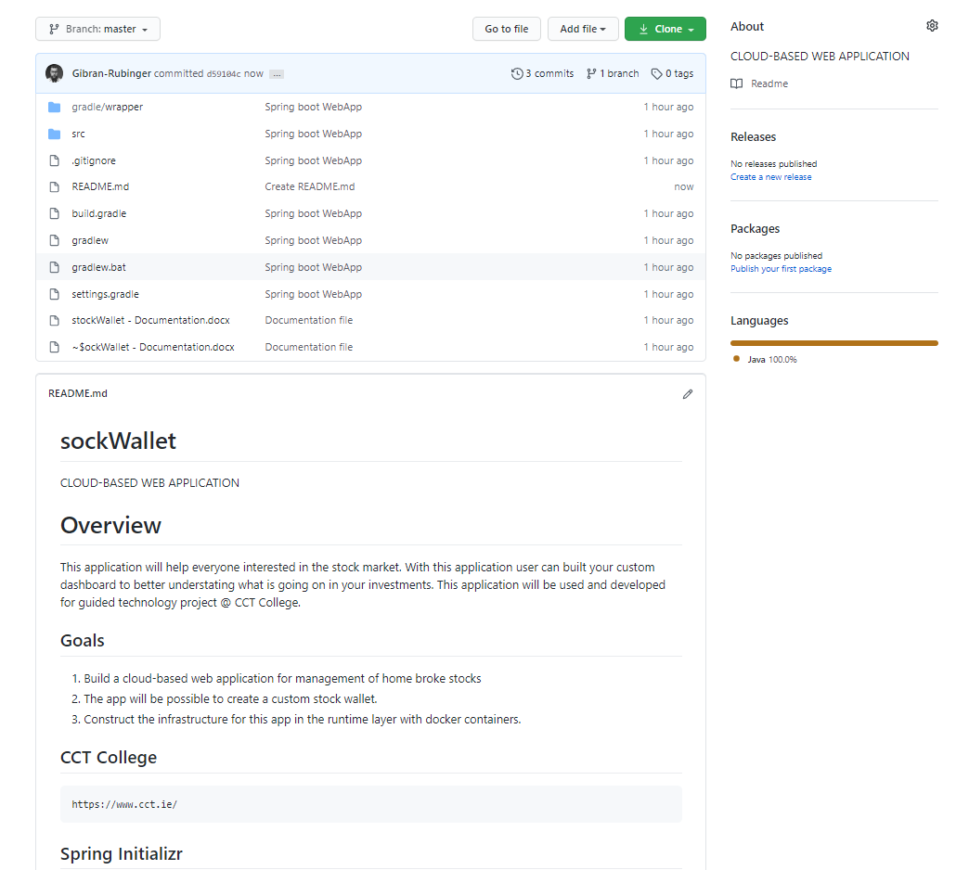

Figure -Screenshot of the GitHub repository

Before to proceed to the next steps is important to describe that Git is a version control program. This version control works as a local repository by saving copies and tracking the changes. This technology comes to the market in 2005 and becomes some of the most powerful tools for software engineers.

On the article *Git vs. Github: what’s the difference?* By Devmountainblog, the article clarifies the difference between both version control:

“*Both Git and GitHub give programmers valuable version-control functionality so that they can build ongoing coding projects without being afraid of messing everything up. GitHub just takes things a little bit further than Git, offering more functionality and resources.”*

Git always works as a local repository, rather than GitHub is a cloud base repository. With GitHub, we can make commits locally and hosting later on a cloud server using GitHub login account.

**String boot**

The Spring boot is a famous framework large using at the industry. since 2000 that provides many features of dependency and can be integrated with others framework as well. So the spring boot gives us all dependency to have a production environment ready for development. Instead of deploying a physical server in ubuntu make virtualization to run it in other Os, deploying a web server such as apache tomcat. This steps can be better orchestrated with spring-boot.

I will try to start the project building a RES API with this framework. First of all, to start the development of this Rest API I will use the Spring Boot to generate an empty project with Spring web dependencies.

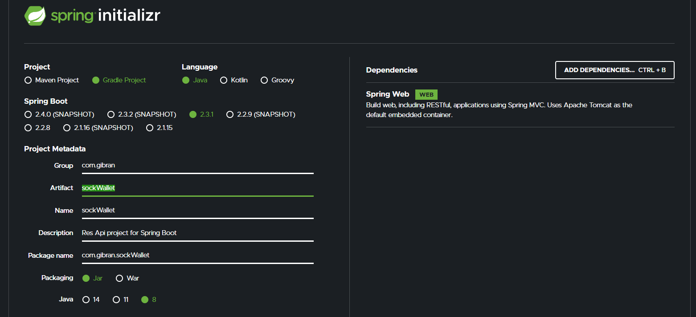

Figure -Screenshot of the creation RestApi – Spring Boot to generate the empty project.

As to clarify what the RES API does the article written by Zell Liew on the Website [smashingmagazine.com](https://www.smashingmagazine.com/2018/01/understanding-using-rest-api/) start with a simple explanation to have an idea what the REST API does:

*“Let’s say you’re trying to find videos about Batman on YouTube. You open up YouTube, type “Batman” into a search field, hit enter, and you see a list of videos about Batman. A REST API works similarly. Your search for something and you get a list of results back from the service you’re requesting from.”*

**API**

The API is responsible to build the applications interface solutions into the server to allow the access and control of clients’ request.

**REST**

The rest will build the configurations of how the API will be settled. As Zell explains:

*“It is a set of rules that developers follow when they create their API. One of these rules states that you should be able to get a piece of data (called a resource) when you link to a specific URL.”*

What is happening on the figure1?

* first its setting witch building tool we want to use. As during the course, we used to use Grade I choose Gradle to automate the JVM.
* It must choose the language we will build on. In my case is Java.
* It will choose the version we are using in Spring Boot in 2.3.1
* fill-up the project metadata with name
* choose the packaging java Application, in my case I will be using Jar as an artefact and deploying that in a single environment that we can use the application in any bare remote machine.
* Choose the java version that matches with my system, 1.8.
* And adding the Spring Web as dependencies

After I download the RestAPI, unzip the files and set up a new workplace in my Eclipse IDE and start to import the Gradle file.

IDE:

Then I integrated Development Environment as the name already explains, is a helper tool for developers that we can write down codes faster than using a text editor. Also, the IDE provides debugger and compiler everything.

**Adding Controller Class**

To able Spring boot find the scanner to connect the Http protocol into the java code I create new class stockWalltController to mapping the request in Http by using annotations for with methods I will use inside this controller.

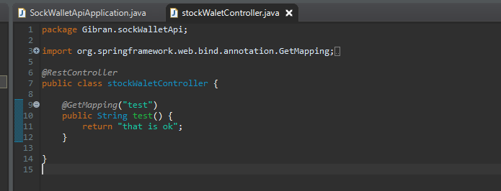

Figure – screenshot of the creation of the class controller.

# Other backgrounds

For this specific project, some other knowledge it will make necessary to implement the application. As the application will care some stock data I start to search about the ISEQ20 and Euronext Dublin, I am trying to understand how the Irish benchmark works.

The ISE20 is a benchmark [stock market index](https://en.wikipedia.org/wiki/Stock_market_index) composed of companies that trade on [Euronext Dublin](https://en.wikipedia.org/wiki/Euronext_Dublin). The index comprises the 20 companies with the highest trading volume and [market capitalisation](https://en.wikipedia.org/wiki/Market_capitalisation) contained within the ISEQ Overall Index. The index was started on 31 December 2004 at a base of 1,000 points. The Irish Overall Index has a long history and is more often used for comparing the performance of the Irish stocks for a longer period.

At Monday (28.06.2020) I will be able to see the market in realtime to understand better how pre prices are sent to the market and I will identify the better brace to take the stock information.

28.06.2020 – Sunday

To start the application my first tasks will mapping the official index composition of ISEQ- All Share

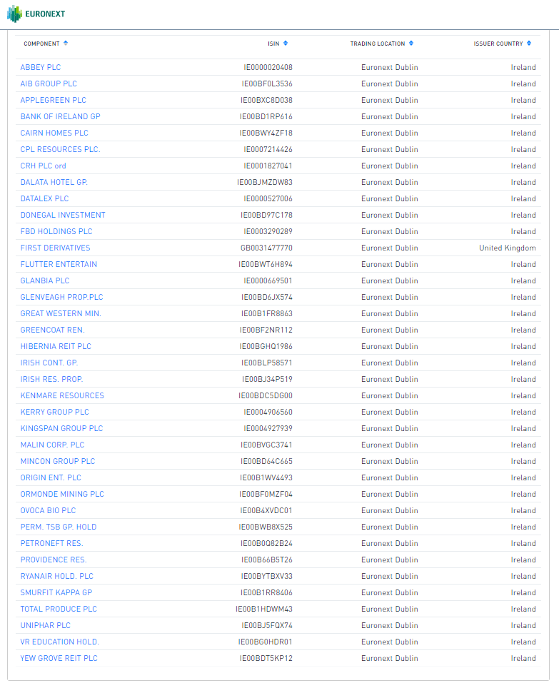

Figure - Screenshot ISEQ All share

As some of the companies are share in other markets to identify the correct one is necessary to have the International Securities Identification Number – ISNI. In a nutshell, this is a unique identifier for each stock.

**Fetch data from Euronext**

To manage to fetch data from the official ISEQ website I will need to implement in my RestApi new library on Gradle this library is jsoup. With jsoup It will be possible crawling data related to ISEQ stocks.

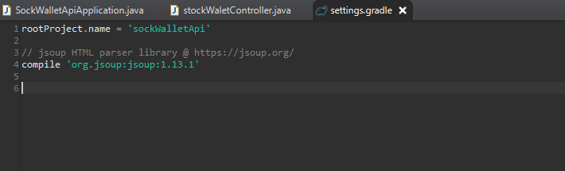

Figure - Jsoup library

As the Jsoup dependencies are not working on Gradle I will try to built again an empty spring boot project and I will take the advantage to add other dependencies to possibility the hibernate works as well.

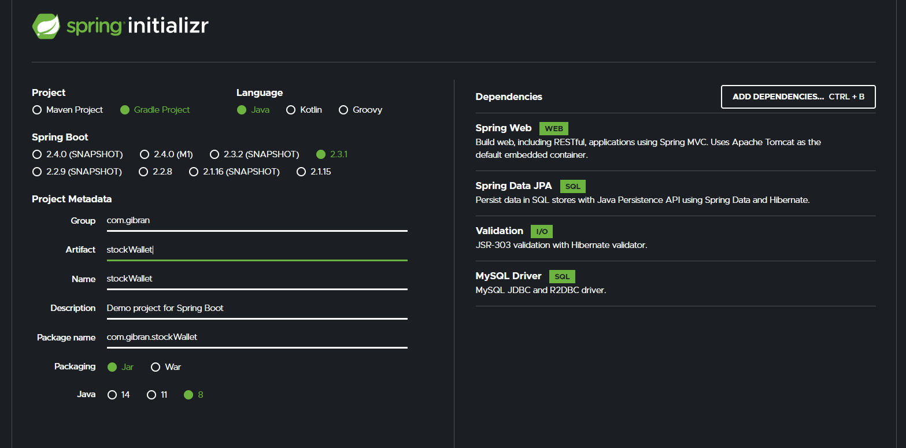

Figure - a new project is done

Even with a new project, the problem persists, until now I was not successful to fix this problem yet.

01.07.2020 – Wednesday

During the last days, I spend to much time seeking for a solution to import the dependencies that I need on Gradle but now I find a solution for it. And was more simple than I imagined. I was trying to create de dependencies when I was making the Gladle, I try to add as library afterwards, try so many steps but nothing was working.

I decide to add the jar file as a new file as the image-9 and built a path image-10 and now is working:

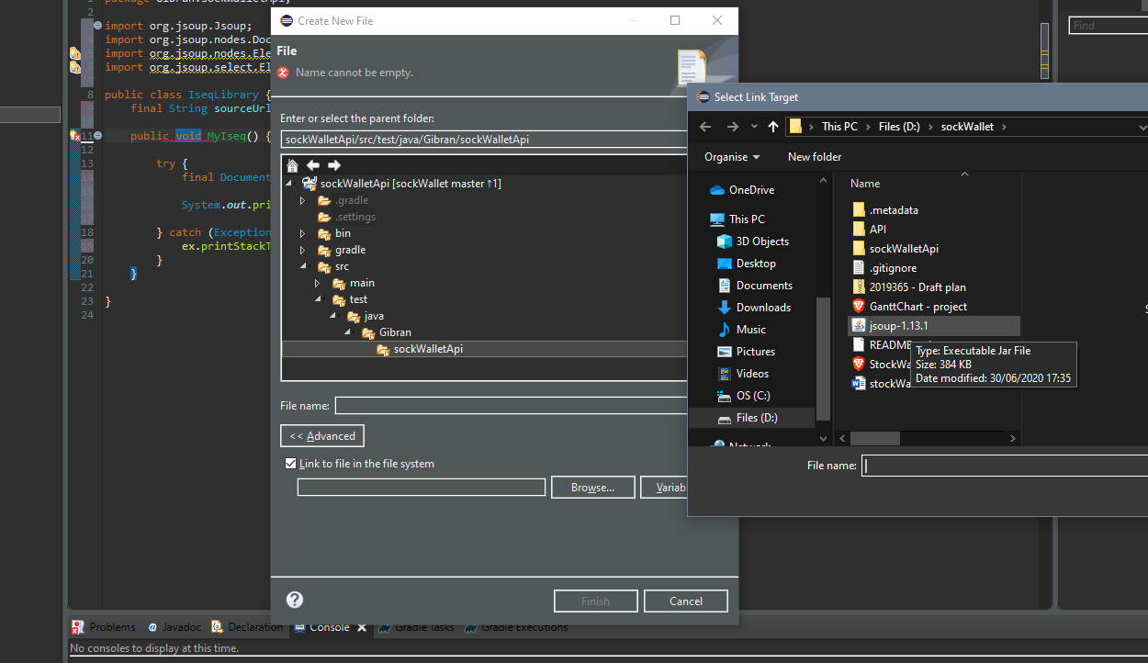

Figure - include the jar library as a file

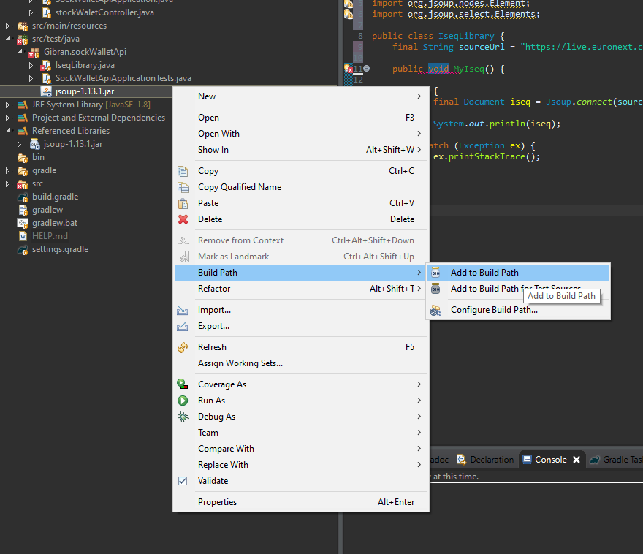

Figure – build path

After trying to use the new library on eclipse my java code was looking fine, it fixes the problems related to import those libraries, but when I run the server many bugs start to pop. As I try so many things to fix the Gradle file somehow I probably broke the file. I decided to rebuild the RestApi from scratch and add the dependencies related to hibernate ( I am planning to use Object-relational mapping) to avoid to do it again on the future. When I import everything again instead to have my project set to use I got this error:

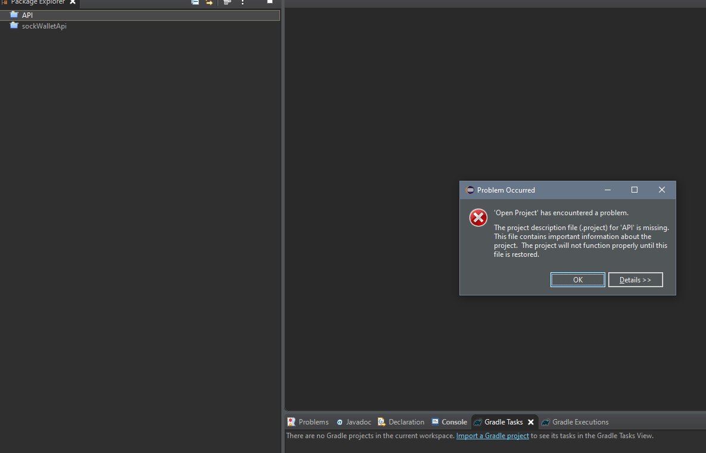

Figure - bug on the application

As the file path still the same as the previous one I will try to delete the metadata to try to fix the import, otherwise, I will lose my git repository as it will be built in another file.

At the first time, it not works, but I add another folder changing the path folder and now it works.

02.07.2020 – Thursday

Today I finally manage how to built the dependencies properly :

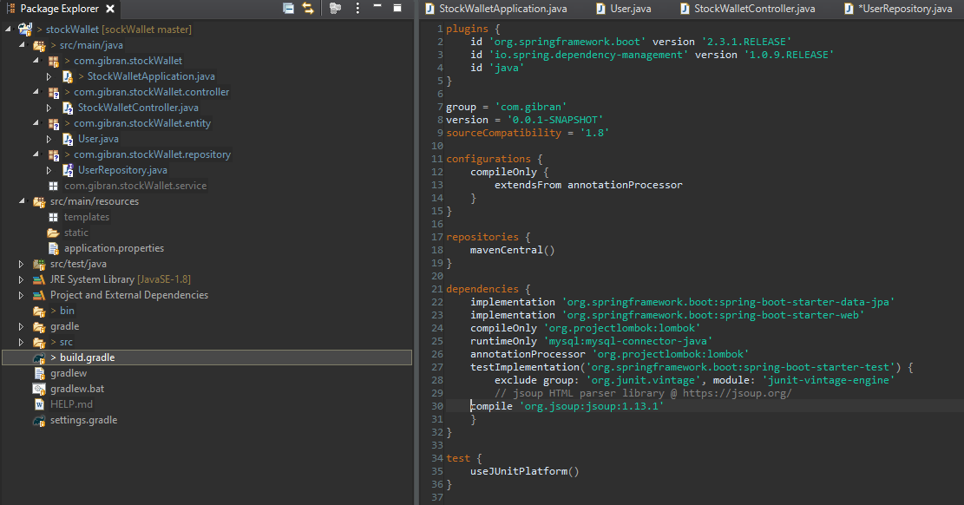

Figure - dependencies on build.gradle

Now I am facing a problem about how to able the SQLDriver to guarantee the connections.

03.07.2020 – Friday

Yesterday I wasn’t able to fix the driver connections but now I am getting close to fixing it.

Some of the reason for this problem was the database connection on the command line. I was unable to connect as the environment variable had no path defined. After to add a new path on the environment I could be able to connect to the MySQL and create a new database as shown in the picture below.

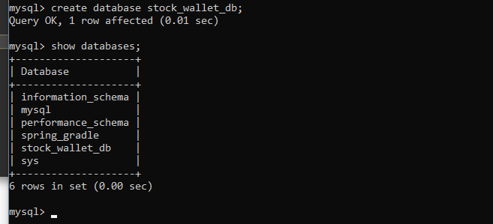

Figure - create a database on MySQL

To be able to create the MySQL driver connection I had to learn how to customised the spring boot from the application.propreties. I had to spend a lot of time until I get in this way. But now I customized the application.properties file as on the picture below:

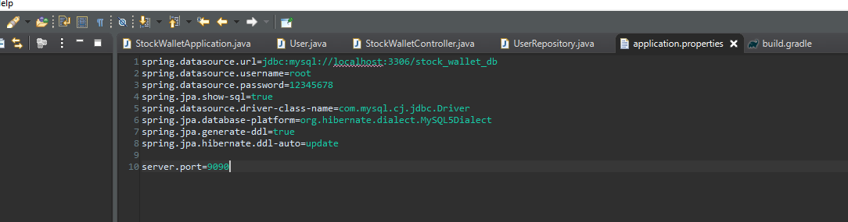

Figure - application.properties file

# **Chapter VI**

# **Conclusions & further work**

# Conclusions

This was the foremost important project I had to take part during the entire course in some of the most difficult moment in my life. we are passing for so many problems in the world, seem everything changes so quickly and everything are going through new directions. To keep the focus, over so many extra hours working to help to keep some essential services for Facebook was extremely hard.

I am glad to take some risk and have an opportunity to learn with all of then. While the application itself was not finished, the learning step I was able to achievement trying to solve the problems, all of this knowledge becomes with me.

For many moments I had to ask myself “why I do not choose a regular project. Probably I will able to Finnish everything!” Now after to pass for the entire process I am very happy for not choose the comfortable path, otherwise many of the process learning until now would not happen.

I believe the real process of learning becomes through the mistakes, with new experiences outside our comfort zone. I think if we put a lot of work and have extra lucky we can be successful at the first try, but in the majority of times, new experiences won't be unsuccessful at the first try. For the learning perspective, now I can understand how important was the short deadline and how big it is this opportunity. Was two months under loads of pressure but the main goal during this process was how to deal with

At the very end, left behind the stressful process, after to handy complete new stuff, open my view for how important is to make decisions. How important is to adopt new situations and how dynamic new elements can be in Computing Science.

References

BrainyQuote. (n.d.). 72 Warren Buffett Quotes - Inspirational Quotes at BrainyQuote. [online] Available at: https://www.brainyquote.com/authors/warren-buffett-quotes [Accessed 28 Jul. 2020].

Gantt.com. (2019). What is a Gantt Chart? Gantt Chart Software, Information, and History. [online] Available at: <https://www.gantt.com/>.

Agantty.com. (2020). [online] Available at: https://app.agantty.com/?locale=en#/gantt [Accessed 28 Jul. 2020].

Sudarsan Reddy (2019). Agile Project Management Methodology — Manifesto, Frameworks and Process. [online] Medium. Available at: https://medium.com/@sudarhtc/agile-project-management-methodology-manifesto-frameworks-and-process-f4c332ddb779.